

Program Implementation Fidelity Measures: Technical Manual

Developed for Colorado Department of Education’s Dropout Prevention and Student Engagement Unit

Elysia Clemens, Ph.D.
Sonja Rizzolo, Ph.D.
Lisa Rue, Ph.D.
Robyn Hess, Ph.D.

Program Implementation Fidelity Measures: Technical Manual

Introduction
This technical manual serves as a guide for using an online survey for sites to develop a site level logic model and a rubric for assessing program implementation fidelity across all five programs. In addition to this technical manual, a Dropbox folder has been created and shared with the Director of the Dropout Prevention and Student Engagement Unit. Housed in this folder are (1) a self-scoring PDF of the Program Implementation Fidelity Rubric and (2) sub-folders for each program containing documents necessary to download the data from the online survey and merge it into a logic model, sample output from a merge, and a list of the items included in the online survey. Included is a PDF of the Program Implementation Fidelity Rubric (p. 7) and sample output of a program level logic model (p.12).

Directions
Programs will be able to easily complete their logic models annually using an online survey tool. They will select from a list of program outcomes, outputs, activities, and resources that match their program implementation. This will be provided to program managers in the form of a word document consistent with the logic model format example. The system developed to evaluate the implementation of programs offered by the DPSEU consists of six steps: 1) distribute the survey to sites in conjunction with planning of site visit, 2) download the data, 3) merge the completed survey results, 4) review of the program’s logic model and original project plan to assess program implementation with the rubric, 5) generate questions for on-site visit, and 6) complete the final rubric and scoring.

Step 1: Distribute Logic Model Survey to Sites

During the site visit planning process send an email to sites including the following language and a link to the survey.

In preparation for our visit, please complete the following survey. 21stCCLC https://unco.us.qualtrics.com/SE/?SID=SV_e3QxsG82zgraS8t

21stCCLC https://unco.us.qualtrics.com/SE/?SID=SV_e3QxsG82zgraS8t
. This survey is designed to create a snapshot of the work that is happening at your site. This survey should be completed by someone who is very familiar with how the program is being implemented and will take approximately 10-20 minutes. You will be asked to indicate from a menu of activities (e.g., interventions, services provided), examples of community partnerships, and program outcomes. Please do not simply copy from the grant/project plan, instead think about what is actually happening at your site. This information will be used to guide some of our discussions during the site visit.

Step 2: Download the Data

Download the results
Go to View Results
Download Data
Under Representation click “Answers as Labels”
Under Export tags, click “Yes”
Click on the CVS Icon

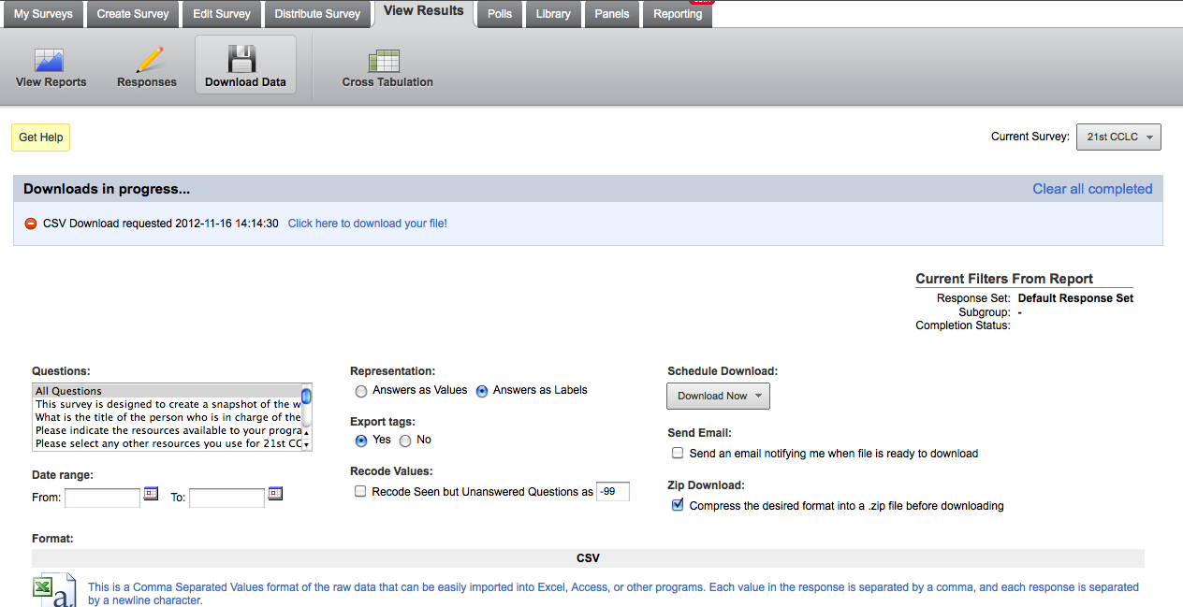

Click on Export Complete and open the File. This file displays all the responses to the survey.

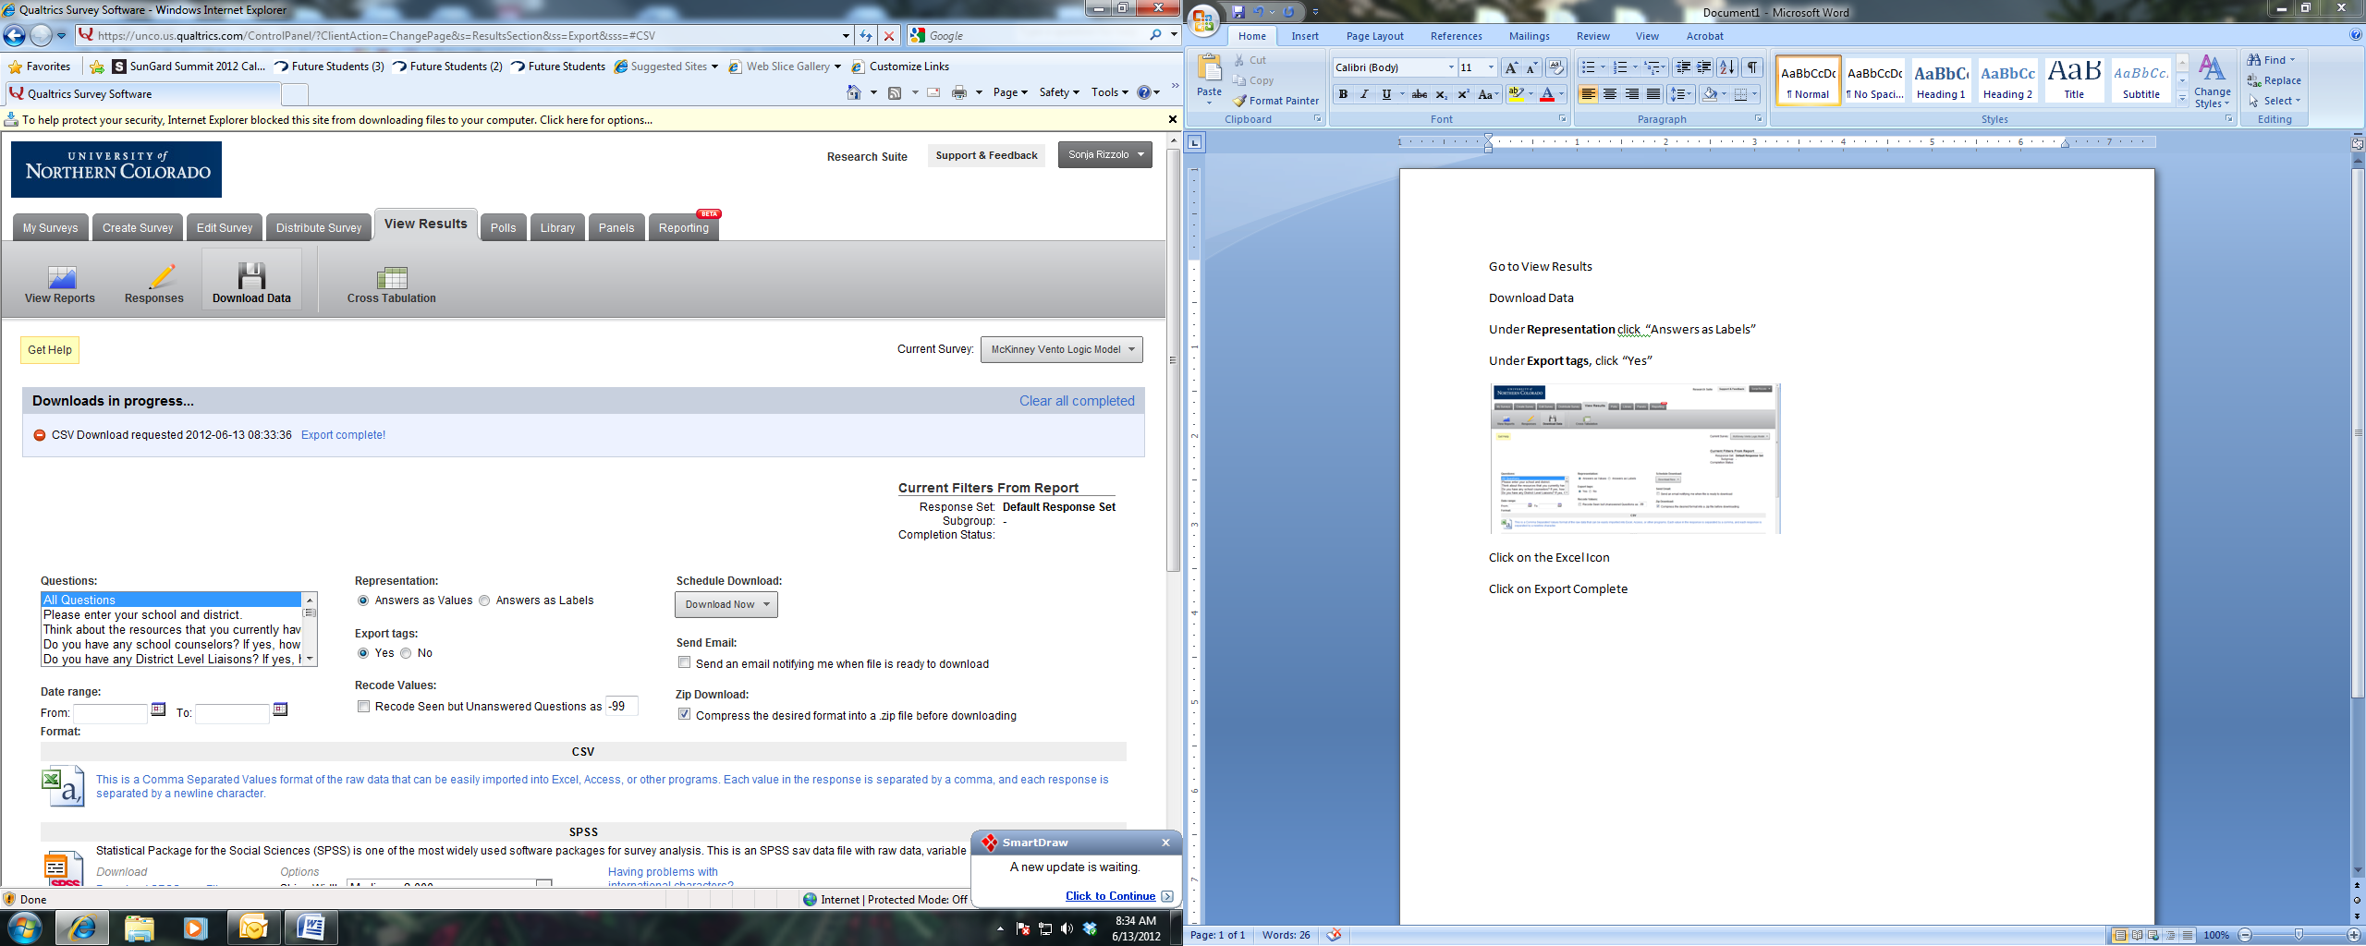
Clean up the Excel File
  - Delete the second row – starts with “response Id” (see table on next page)
  - Delete the First 14 columns: V1, V2, V3, V4, V5, V6, V7, V8, V9, V10, SCO_0, SCO_1, SCO_2, Q#* (see table on next page). The Excel file should start with Column Q0 (Question 0)
  - Save this file as a CSV File (Comma delimited) on your desktop or different space. After the file is saved, you can close it. *Number depends on the survey. The file should always start with Q0.

V1 | V2 | V3 | V4 | V5 | V6 | V7 | V8 | V9 | V10 | SCO_0 | SCO_1 | SCO_2 | Q# | Q0
Response ID | ResponseSet | Name | External Data  Reference | Email  Address | IP  Address | Status | Start  Date | End  Date | Finished | Grade-sum | Grade-weighted Avg | Grade-weightedStdDev |  | Please enter your school and district.
R_eKwkwU | Default Response Set | Anonymous |  |  |  | 1 | 3/7/2012 7:41:20 AM | 3/7/2012 7:46:00 AM | 1 | 2 | 1 | 0 |  | Greeley West
R_dbgqkdRT81IAaQQ | Default Response Set | Anonymous |  |  |  | 1 | 3/7/2012 10:10:35 AM | 3/7/2012 10:14:18 AM | 1 | 1 | 1 | 0 |  | Greeley West

Step 3: Merge the Data into Word

Open the WORD logic model template and complete a Mailmerge. These word documents are program specific and are currently housed in a Dropbox folder shared with the Director of DPSEU.

Click on “No” when asked the following question, “Data from your database will be placed in the document. Do you want to continue?”

Start Mailmerge
- Click on “Mailings”
- Start Mail Merge
- Step By Step Mail Merge Wizard
- Follow the steps at the bottom of the page
- Next: Starting document
- Next: Select recipients – Browse and go to your saved Excel file, hit OK, OK
- Next: Write your letter
- Next: Preview your letters
- Next: Complete the merge
- Click on Print, All, and Print and/or save the logic models
//
When printing is complete you can close the file, and click on “No” when it asks you if you would like to save the changes.

Step 4: Review Logic Model, Program Plan with Program Implementation Fidelity Rubric

The logic model is a snapshot of what the person completing the survey believes to be happening at the site. The initial review of the program’s logic model, in conjunction with the site’s project plan (e.g., grant proposal) should be completed in advance of the site visit using the Program Implementation Fidelity Rubric. The goal of the review of the logic model is to identify important discussion points during the site visit and to provide support, guidance, and feedback to the site. In addition, this review will create the foundation for measuring program implementation fidelity.

Please use the table 1 as a guide for when to refer to the logic model and when to refer to the project plan when completing the Program Implementation Fidelity Rubric. For example, to score Item 1: “Personnel and Leadership Indicators”, please review the “Staffing and Resources” and “Outputs” column in the Logic Model. To rate Item 6 “Congruency”, please look at the congruency between the activities listed in the logic model and the activities described in the project plan.
/
Table I Logic Model and Rubric Matrix

 | Logic Model Components |  |  |  |  |  | Project  Plan
 | Staffing and Resources | Activities | Outputs  Internal/  External | Short-Term (proximal)  Outcomes | Long-Term  (distal)  Outcomes | Community  Features | Project  Plan Submitted by Site
Item1.  Levels of ImplementationRubric  Personnel and Leadership Indicators | X |  | X
Item 2.  Process Level Indicators |  | X | X
Item 3.  Evidence Based Programs |  | X |  | X | X
Item 4.  Clear Linkages |  | X | X | X | X
Item 5.  Feedback Loop |  | X | X
Item 6.  Congruency |  | X |  |  |  |  | X
Item 7.  Sustainability |  |  |  |  |  | X | X
The Program Implementation Fidelity Rubric is self-scoring, meaning that if used online it will total the scores for the CDE staff member. The writable PDF version that will allow for this self-scoring function is currently located in the same Dropbox folder as the Word mail merge templates.

Step 5: Generate Questions for the Site Visit

The review of the logic model allows for the development of questions for the site visit. These questions will either confirm the initial review of program implementation illustrated by the logic model, or provide new evidence that may adjust the score for the level of implementation.

Step 6: Complete the Final Rubric and Score

Once the site visit is complete, the program manager will enter the implementation score for the seven items into an online version of the PDF that will be housed in both the Unit-wide online reporting system and EZReports. This will automatically generate a final implementation score by calculating total points earned on each item. The final score will be provided back to each of the site-level program directors through a process determined by the Unit.

