Content Area | World Languages |  |  | Proficiency Range Level | Novice Mid
Course Name/Course Code
Standard | Grade Level Expectations (GLE) |  |  |  |  |  | GLE Code
- Communication in Languages Other Than English | - Participate in basic conversations (written or oral) on a variety of familiar and predictable topics using isolated words and learned phrases (interpersonal mode) |  |  |  |  |  | WL09-NM-S.1-GLE.1
- Communication in Languages Other Than English | - Comprehend short learned exchanges (written or oral) on learned topics that use learned vocabulary and grammatical structures (interpretive mode) |  |  |  |  |  | WL09-NM-S.1-GLE.2
- Communication in Languages Other Than English | - Present using learned and simple phrases or expressions (written or oral) on very familiar topics (presentational mode) |  |  |  |  |  | WL09-NM-S.1-GLE.3
- Knowledge and Understanding of Other Cultures | - Reproduce common practices of the cultures studied |  |  |  |  |  | WL09-NM-S.2-GLE.1
- Knowledge and Understanding of Other Cultures | - Describe familiar products of the cultures studied |  |  |  |  |  | WL09-NM-S.2-GLE.2
- Connections with Other Disciplines and Information Acquisition | - Summarize information gathered from target language resources connected to other content areas |  |  |  |  |  | WL09-NM-S.3-GLE.1
 | - Organize information acquired from authentic resources |  |  |  |  |  | WL09-NM-S.3-GLE.2
- Comparisons to Develop Insight into the Nature of Language and Culture | - Expand knowledge of similarities and differences of basic structural patterns of language through comparisons of the student’s own language and the language studied |  |  |  |  |  | WL09-NM-S.4-GLE.1
 | - Investigate the nature of culture through comparisons of the target culture(s) and the student’s own culture and how the two cultures interact |  |  |  |  |  | WL09-NM-S.4-GLE.2
Colorado 21st Century Skills  Critical Thinking and Reasoning: Thinking Deeply, Thinking Differently  Information Literacy: Untangling the Web  Collaboration: Working Together, Learning Together  Self-Direction: Own Your Learning  Invention: Creating Solutions |  | 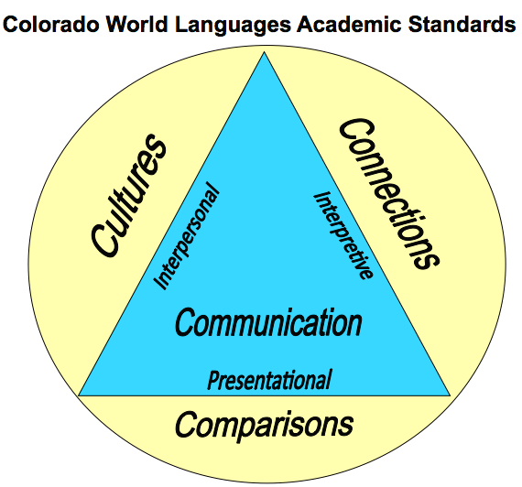  The Colorado World Languages Standards describe what learners should know and be able to do as they develop proficiency in a foreign language. Communication is at the center using the interpersonal, interpretive and presentational modes. Communication is then supported by understanding cultural perspectives, making connections to other disciplines and comparing one’s own language and culture with the new language.
Unit Titles |  |  | Length of Unit/Contact Hours |  |  | Unit Number/Sequence
Mealtimes and Celebrations |  |  | 3 Weeks = 15 Days = 15 Hours

Unit Title | Mealtimes and Celebrations |  | Length of Unit |  | 3 Weeks = 15 Days = 15 Hours
Focusing Lens(es) | Tradition | Standards and Grade Level Expectations Addressed in this Unit |  | WL09-NM-S.1-GLE.1; WL09-NM-S.1-GLE.2; WL09-NM-S.1-GLE.3;  WL09-NM-S.2-GLE.1; WL09-NM-S.2-GLE.2;  WL09-NM-S.3-GLE.1; WL09-NM-S.3-GLE.2;  WL09-NM-S.4-GLE.1; WL09-NM-S.4-GLE.2
Inquiry Questions (Engaging- Debatable): | - Why does every culture have its own traditions and practices regarding foods?
Unit Strands | 1. Communication in Languages Other Than English 2. Knowledge and Understanding of Other Cultures  3. Connections with Other Disciplines and Information Acquisition 4. Comparisons to Develop Insight into the Nature of Language and Culture
Foundational Concepts in World Languages | Interpersonal Communication, Interpretive Communication, Presentational Communication, Cultures, Connections, Comparisons
Concepts | Tradition, Practices, Diversity, Family, Daily life, Celebrations

Generalizations  My students will Understand that… | Guiding Questions  Factual Conceptual
Mealtime traditions in the target cultures create opportunities to examine and explore deeper perspectives of family life. | What are typical American family mealtime traditions?  What are mealtime traditions like in the target culture? | How do mealtime traditions reflect daily life?  Why is it important to learn about different cultural traditions regarding food?
Fuller participation in the target cultures occurs through studying typical foods and eating habits practiced by the target cultures. | What are the traditional products, practices and perspectives regarding foods and eating habits in the target culture? WL09-NM-S.2-GLE.1-EO.b & c | How does an understanding of the relationship between the products, practices and perspectives of a given culture allow people to communicate and connect with those who speak the target language? WL09-NM-S.2-GLE.1-IQ.1
Cultural traditions reflected in the foods/dishes eaten during celebrations promote a greater appreciation of the target culture. | What are the foods/dishes eaten during celebrations of the target cultures? | How do celebrations reflect the significance of foods/dishes within cultures?

Critical Content:  My students will Know… |  | Key Skills:  My students will be able to (Do)…
Culture: | - Celebrations/Holidays  - Family meal traditions | Within the context of this unit, students will be able to demonstrate in the target language the three modes of communication – interpersonal, interpretive and presentational. Some examples can include, but may not be limited to:  - Ask and answer questions  - Compare and contrast eating habits  - Describe major traditions and celebrations WL09-NM-S.2-GLE.1-EO.c  - Examine the use and relevance of common daily products WL09-NM-S.2-GLE.2-EO.a  - Express likes and dislikes  (WL09-NM-S.1-GLE.1) and (WL09-NM-S.1-GLE.2) and (WL09-NM-S.1-GLE.3)
Context: | - Calendar  - Celebrations/Holidays  - Clock/Time  - Food  - Mealtimes  - Question words  - Traditions
Structure: | - Adjective agreement  - Present tense  - Question formation
Connections to: | - Family and Consumer Science  - Math  - Social Studies

Critical Language: includes the Academic and Technical vocabulary, semantics, and discourse which are particular to and necessary for accessing a given discipline.
Academic Vocabulary: | compare, contrast, discuss, tell, express, answer, ask, reflect, share, describe
Technical Vocabulary: | interpersonal, interpretive, presentational, grammatical terms, practices, products, perspectives, connections, performance, proficiency range

