Content Area | World Languages |  |  | Proficiency Range Level | Novice High
Course Name/Course Code
Standard | Grade Level Expectations (GLE) |  |  |  |  |  | GLE Code
- Communication in Languages Other Than English | - Participate in exchanges (written or oral) on a variety of familiar topics using familiar vocabulary and learned grammatical structures (interpersonal mode) |  |  |  |  |  | WL09-NH-S.1-GLE.1
- Communication in Languages Other Than English | - Comprehend exchanges (written or oral) on a variety of familiar topics using both high-frequency vocabulary, new vocabulary, and learned grammatical structures (interpretive mode) |  |  |  |  |  | WL09-NH-S.1-GLE.2
- Communication in Languages Other Than English | - Present (written or oral) on a variety of familiar topics using both high-frequency vocabulary, new vocabulary, and learned grammatical structures (Presentational mode) |  |  |  |  |  | WL09-NH-S.1-GLE.3
- Knowledge and Understanding of Other Cultures | - Examine common practices and perspectives within the cultures studied |  |  |  |  |  | WL09-NH-S.2-GLE.1
- Knowledge and Understanding of Other Cultures | - Examine familiar products of the cultures studied |  |  |  |  |  | WL09-NH-S.2-GLE.2
- Connections with Other Disciplines and Information Acquisition | - Examine information gathered from target language resources connected to other content areas |  |  |  |  |  | WL09-NH-S.3-GLE.1
 | - Relate information acquired from authentic resources to individual perspectives and experiences |  |  |  |  |  | WL09-NH-S.3-GLE.2
- Comparisons to Develop Insight into the Nature of Language and Culture | - Describe similarities and differences between structural patterns of the target language through comparisons of the student’s own language and the language studied |  |  |  |  |  | WL09-NH-S.4-GLE.1
 | - Describe the nature of culture through comparisons of the target culture(s) and the student’s own culture and how the two cultures interact |  |  |  |  |  | WL09-NH-S.4-GLE.2
Colorado 21st Century Skills  Critical Thinking and Reasoning: Thinking Deeply, Thinking Differently  Information Literacy: Untangling the Web  Collaboration: Working Together, Learning Together  Self-Direction: Own Your Learning  Invention: Creating Solutions |  | 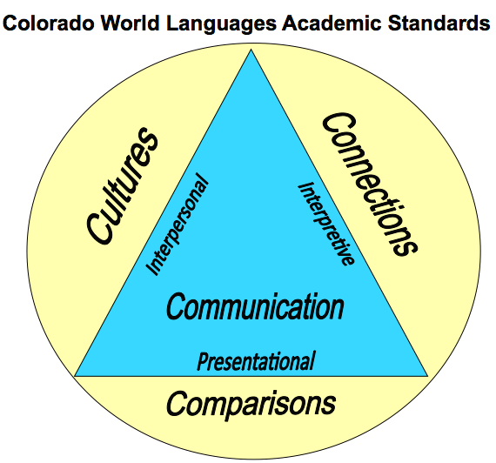  The Colorado World Languages Standards describe what learners should know and be able to do as they develop proficiency in a foreign language. Communication is at the center using the interpersonal, interpretive and presentational modes. Communication is then supported by understanding cultural perspectives, making connections to other disciplines and comparing one’s own language and culture with the new language.
Unit Titles |  |  | Length of Unit/Contact Hours |  |  | Unit Number/Sequence
Stories, Legends and Fables |  |  | 4 Weeks = 20 Days = 20 hours

Unit Title | Stories, Legends and Fables |  | Length of Unit |  | 4 Weeks = 20 Days = 20 hours
Focusing Lens(es) | Values | Standards and Grade Level Expectations Addressed in this Unit |  | WL09-NH-S.1-GLE.1; WL09-NH-S.1-GLE.2; WL09-NH-S.1-GLE.3;  WL09-NH-S.2-GLE.1; WL09-NH-S.2-GLE.2;  WL09-NH-S.3-GLE.1; WL09-NH-S.3-GLE.2;  WL09-NH-S.4-GLE.1; WL09-NH-S.4-GLE.2
Inquiry Questions (Engaging- Debatable): | - Why does every culture have their own stories and what lessons can we learn through these stories?
Unit Strands | 1. Communication in Languages Other Than English 2. Knowledge and Understanding of Other Cultures  3. Connections with Other Disciplines and Information Acquisition 4. Comparisons to Develop Insight into the Nature of Language and Culture
Foundational Concepts in World Languages | Interpersonal Communication, Interpretive Communication, Presentational Communication, Cultures, Connections, Comparisons
Concepts | Identity, Values, Relationships, Behavior, Customs, Norms,

Generalizations  My students will Understand that… | Guiding Questions  Factual Conceptual
Stories shared from other cultures define identity and help build relationships among people. | What are important stories in the target culture? | How do stories form strong bonds between people?
Stories teach lessons about social norms and appropriate behavior to help individuals understand accepted norms in the target cultures. | What cultural norms are embedded in the stories? | How do stories teach people about social norms?
Stories, legends, and fables allow individuals to connect with and gain appreciation of the language and customs of a target culture. | What culture and customs appear in stories, legends, and fables? | How are cultural values reflected in the stories, legends, and fables?

Critical Content:  My students will Know… |  | Key Skills:  My students will be able to (Do)…
Culture: | - Stories  - Legends  - Tales  - Myths  - Cultural Norms and Values | Within the context of this unit, students will be able to demonstrate in the target language the three modes of communication – interpersonal, interpretive and presentational. Some examples can include, but may not be limited to:  - Read to understand plot, character and setting.  - Identify the cultural values reflected in stories, legends, tales and/or myths.  - Listen to and understand the main idea of a story.  - Narrate a story.  - Summarize the main idea of a story.  - Compare and contrast stories  (WL09-NH-S.1-GLE.1) and (WL09-NH-S.1-GLE.2) and (WL09-NH-S.1-GLE.3)
Context: | - Story-related vocabulary  - Character descriptions  - Places
Structure: | - Verb tenses  - Sequencing  - Sentence structure  - Adjectives  - Adverbs
Connections to: | - History  - Geography  - Language Arts

Critical Language: includes the Academic and Technical vocabulary, semantics, and discourse which are particular to and necessary for accessing a given discipline.
Academic Vocabulary: | Ask, answer, compare, contrast, imagine, explain, paraphrase, summarize, reflect, recognize
Technical Vocabulary: | interpersonal, interpretive, presentational, grammatical terms, practices, products, perspectives, connections, performance, proficiency range

