Student Name ________________________________________ Date ____________

Picture My Story
Dear Parent,
We are learning about the parts of a book. One important part is the cover because it gives
us important information about the story. I hope you enjoy this activity with your child. This assignment is due __________________________________. Thank you!

THINGS TO REMEMBER

The title of a book will help you decide if you want to read it.
The author wrote the book.
The illustrator drew the pictures for the book.

LET’S DO THIS

- Ask your child: Use the words in the box to label the title, author, and illustrator
on this book cover.
author title illustrator

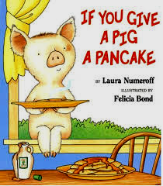

- Tell your child: Some books are FICTION.
They tell a made-up story, but they are NOT TRUE.

Some books are NON-FICTION.
They give information. They are TRUE.

- Ask your child: Look at the cover of the book.

Circle if this book is FICTION or NON-FICTION

Why do you think that?

LET’S DO THIS

- Ask your child: Write fiction (made up story) or non-fiction (true information)
below these book covers. The first one is done for you.



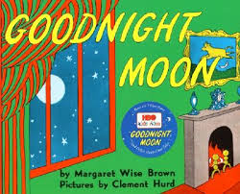
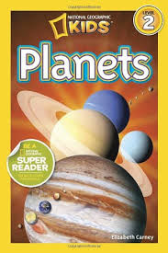

non-fiction _________________________ _______________________ _____________________

- Ask your child: What is one of your favorite books? ______________________

Why do you like this book?

Circle if this book is FICTION or NON-FICTION

Why do you think that?

HOME-TO-SCHOOL COMMUNICATION

Dear Parent,

Please give your reactions to your child’s work on this activity.
Write YES or NO for each statement.
______ 1. My child understood the homework and was able to complete it.
______ 2. My child and I enjoyed the activity.
______ 3. This assignment helped me know what my child is learning in class.

Comment ________________________________________________________________________

Parent Signature __________________________________________________________________

Wilshusen, M., Bognar, J., Handy, T., Epstein, J., & Greenfeld, M. (2016). Teachers Involve Parents in Schoolwork (TIPS) Interactive Homework-Literacy K-3. Colorado Series. Baltimore: Center on School, Family, and Community Partnerships, Johns Hopkins University.

